# **Final Project: Proposal**

## Manoj Gulati (PhD-1327)

## Course Name: Smart Electronic System Design Paradigm

## Instructor: Mr. Kishore Narang

## Idea #1: Design of a HPF (High Pass Filter) for sensing Common Mode and Differential Mode components of Conducted EMI present in AC Power line.

Conducted EMI is a high frequency noise generated from SMPS, essentially due to use of high speed switching circuits used in DC-DC converters, or AC-DC converters. Conducted EMI is generated due to non-linear current consumption of these Switched Mode Power Supplies (or SMPS). Conducted EMI is further coupled either differentially between phase-neutral or in common between phase-earth and neutral-earth. Previously some research has been done to utilize Differential Mode EMI to identify appliances on power line [1]. As each electronic appliance is having a specific SMPS, generating EMI at a particular switching frequency, this signature can be used to uniquely detect appliances. This work forms a part of Non-Intrusive Load Monitoring (or NILM) research [2]. NILM is a technique used to infer constituent appliances contributing to the overall energy consumption, using a single point metering system, deployed at mains power inlet. As energy efficiency is considered as the sixth fuel which can help in achieving the goal of long term energy sustainability. Real time end-user energy feedback using appliance level power consumption can play a pivotal role in achieving this goal.

Our current goal is to design a HPF which can separate both CM and DM components of Conducted EMI, so that these individual signals can be used to characterize appliances.

Previous HPF design used in our study, for Differential Mode Conducted EMI sensing is shown below [5]:

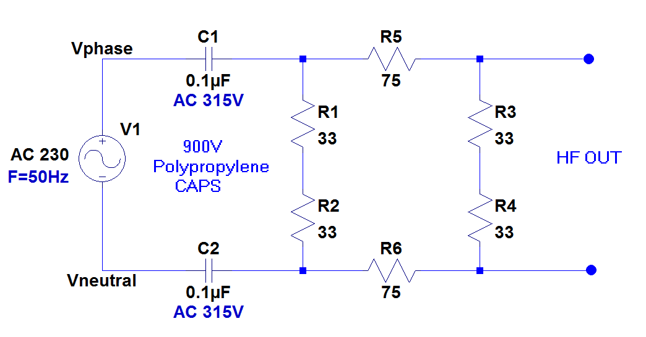

A block diagram showing LISN (Line Impedance Stabilization Network) used to separate Common Mode and Differential Mode components of Conducted EMI [3].



## Idea #2: Design of a wideband analog front end for sensing complete power line spectrum from 0-30MHz.

The goal of this project is to design a single circuit for sensing whole power line spectrum. Some systems exist for power quality monitoring, having an operational range from 0 Hz - 2.5 kHz (50th Harmonic of AC sinusoid), but they find limited usage due to higher cost (>$2-4000) [4]. Some systems have been designed by NILM community as well for harmonic analysis (up to 50th harmonic) and separately for EMI sensing (50 kHz - 30 MHz). With this new sensing circuit we will be able to characterize an appliance under test (AUT), using both harmonic as well as conducted emissions. These two diverse features can be leveraged for power quality monitoring and appliance level profiling. So far no such work exist in literature which has exploited both of these features jointly.

Note: If the time frame allows, I would like to complete both of these designs as they are equivalently important for my current research. But the first design is having higher priority right now.

References:

1. Gupta, Sidhant, Matthew S. Reynolds, and Shwetak N. Patel. "ElectriSense: single-point sensing using EMI for electrical event detection and classification in the home." *Proceedings of the 12th ACM international conference on Ubiquitous computing*. ACM, 2010.
2. Hart, George William. "Nonintrusive appliance load monitoring." *Proceedings of the IEEE* 80.12 (1992): 1870-1891.
3. Caponet, Marco Chiado, and Francesco Profumo. "Devices for the separation of the common and differential mode noise: design and realization." *Applied Power Electronics Conference and Exposition, 2002. APEC 2002. Seventeenth Annual IEEE*. Vol. 1. IEEE, 2002.
4. <http://in.element14.com/fluke/fluke-1735/analyser-power-57v-830v-1a-10a/dp/1272821>
5. <http://hfed.github.io>